
Draft Agenda

April 2, 2025
7:00 – 8:30 pm

- Meeting Called to Order – Sara Burke Kral
- Introductions
- Review and Approval of Agenda – Sara Burke Kral
- Growth and Development Speaker Series - Presentation #2

“BUILDING RESILIENCE IN URBAN AND RURAL STREAMS”

GLEN LEVERICH | PRINCIPAL GEOMORPHOLOGIST, WOLF WATER RESOURCES
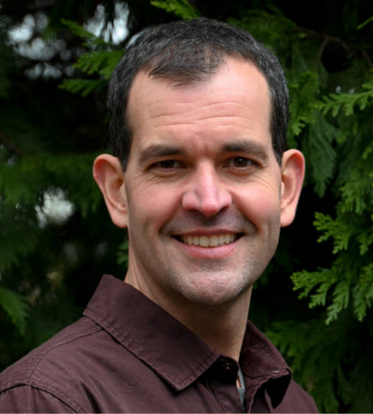
Glen is a geomorphologist and licensed geologist with expertise in watershed assessment, environmental planning, geomorphic and hydrologic analyses, restoration planning, and regulatory permitting. Through his 25-year career, he has applied his technical, management, and communication skills to help various client types understand complex biophysical processes and arrive at science-forward, community-supported solutions to environmental resource management. Glen has played key roles in numerous project types and settings throughout the western U.S. in resolving preconceived conflicts between biophysical dynamics and anthropogenic activities by identifying natural resource assets that, through conservation or restoration, can simultaneously benefit both ecological and land-use needs.
- Public Comment
- Approval of March 2025 Minutes
- Adjourn

